

Primary Care PTSD Screen for DSM-5 (PC-PTSD-5)

Version date: 2022
Reference: Prins, A., Bovin, M. J., Kimerling, R., Kaloupek, D. G, Marx, B. P., Pless Kaiser, A., & Schnurr, P. P. (2015). Primary Care PTSD Screen
for DSM-5 (PC-PTSD-5) [Measurement instrument]. Available from https://www.ptsd.va.gov
URL: https://www.ptsd.va.gov/professional/ assessment/screens/pc-ptsd.asp

PC-PTSD-5

Description

The Primary Care PTSD Screen for DSM-5 (PC-PTSD-5) is a 5-item screen designed to identify individuals with probable PTSD. Those screening positive require further assessment, preferably with a structured interview.

Scoring

The measure begins with an item designed to assess whether the respondent has had any exposure to traumatic events. If a respondent denies exposure, the PC-PTSD-5 is complete with a score of 0.
If a respondent indicates a trauma history – experiencing a traumatic event over the course of their life – the respondent is instructed to answer five additional yes/no questions (see below) about how that trauma has affected them over the past month.
Respondents can score a 0-5, which is a count of "yes" responses to the 5 questions below. Research in a large sample of VA primary care patients found that a cut-point of 4 ideally balanced false negatives and false positives for the overall sample and for men. However, for women, a cut-point of 4 resulted in high numbers of false negatives. Practitioners may consider a lower cut-point for women in some settings if evaluation resources are available. In contrast, a higher cut-point may be preferable if resources are such that false positives will substantially decrease clinician availability. Because performance parameters will change according to sample, clinicians should consider sample characteristics and screening purposes when selecting a cut-point.

Example
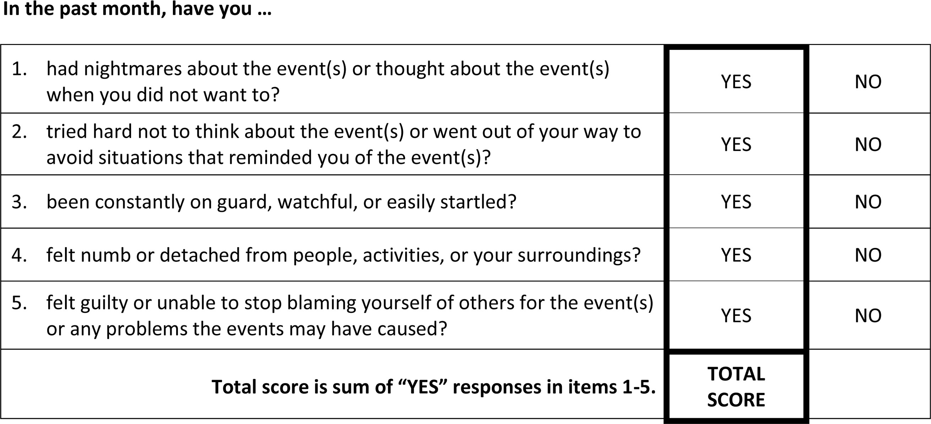

ID #
PC-PTSD-5

Sometimes things happen to people that are unusually or especially frightening, horrible, or traumatic. For example:
- a serious accident or fire
- a physical or sexual assault or abuse
- an earthquake or flood
- a war
- seeing someone be killed or seriously injured
- having a loved one die through homicide or suicide.
Have you ever experienced this kind of event?
YES NO
If no, screen total = 0. Please stop here.
If yes, please answer the questions below.

In the past month, have you…

- had nightmares about the event(s) or thought about the event(s) when you did not want to? YES NO
- tried hard not to think about the event(s) or went out of your way to avoid situations that reminded you of the event(s)?
YES NO

- been constantly on guard, watchful, or easily startled? YES NO
- felt numb or detached from people, activities, or your surroundings? YES NO
- felt guilty or unable to stop blaming yourself or others for the event(s) or any problems the event(s) may have caused?
YES NO

