

Family Needs
Our interventions address youth and family issues such as:
- Delinquency & court involvement
- Truancy or academic failure
- Substance use disorders
- Risk of removal or incarceration
- Aggressive or risky behavior
- Family conflicts
- Mental & behavioral health challenges

Overview
For youth involved in the juvenile justice system, it can often feel like a highway with only one exit ramp: incarceration.
Multisystemic Therapy (MST) offers an alternative path by reducing and
preventing juvenile delinquency. Instead of sending youth out of the community, therapists work in the home, addressing the root causes and fostering a positive family dynamic.

Who We Serve
Benefits
- 24/7 crisis intervention
- Improves behavior & reduces family conflict
- Improves family harmony & stability
- Helps prevent further involvement with the juvenile justice system
- Increases positive interactions within schools & communities
- Reduces mental health difficulties
MST empowers youth ages 12-17 years old and their families to function responsibly in the long-term. It serves youth at risk
of abuse, neglect, or placement outside the home because of their challenging behaviors. Caregivers receive support in developing parenting techniques to manage conflict and other challenges.

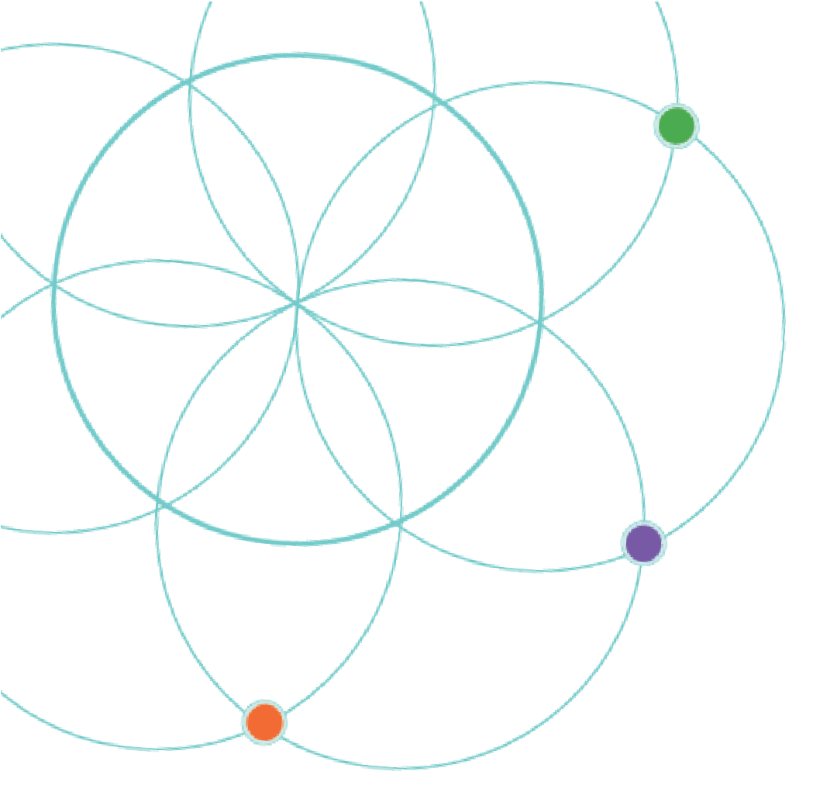

A therapist is assigned
to each family.
Crisis intervention is available 24/7 to address safety issues and prevent placement of a child.
Families receive services for 3-5 months while involved with different systems.

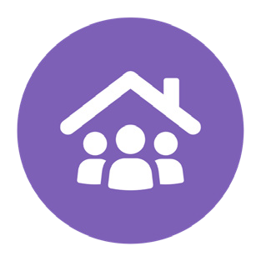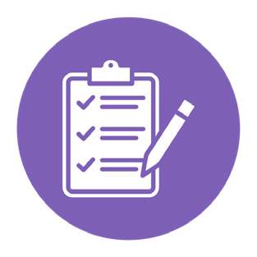

The therapist helps with safety & crisis planning & crisis management when needed. Services are delivered in the family's home or community.
Therapists provide a broad range of services specific to each family. This can include: assessments, addressing family conflict, therapy for trauma & PTSD, anger management training, parenting skills training, and improving family
communication and problem-solving skills.

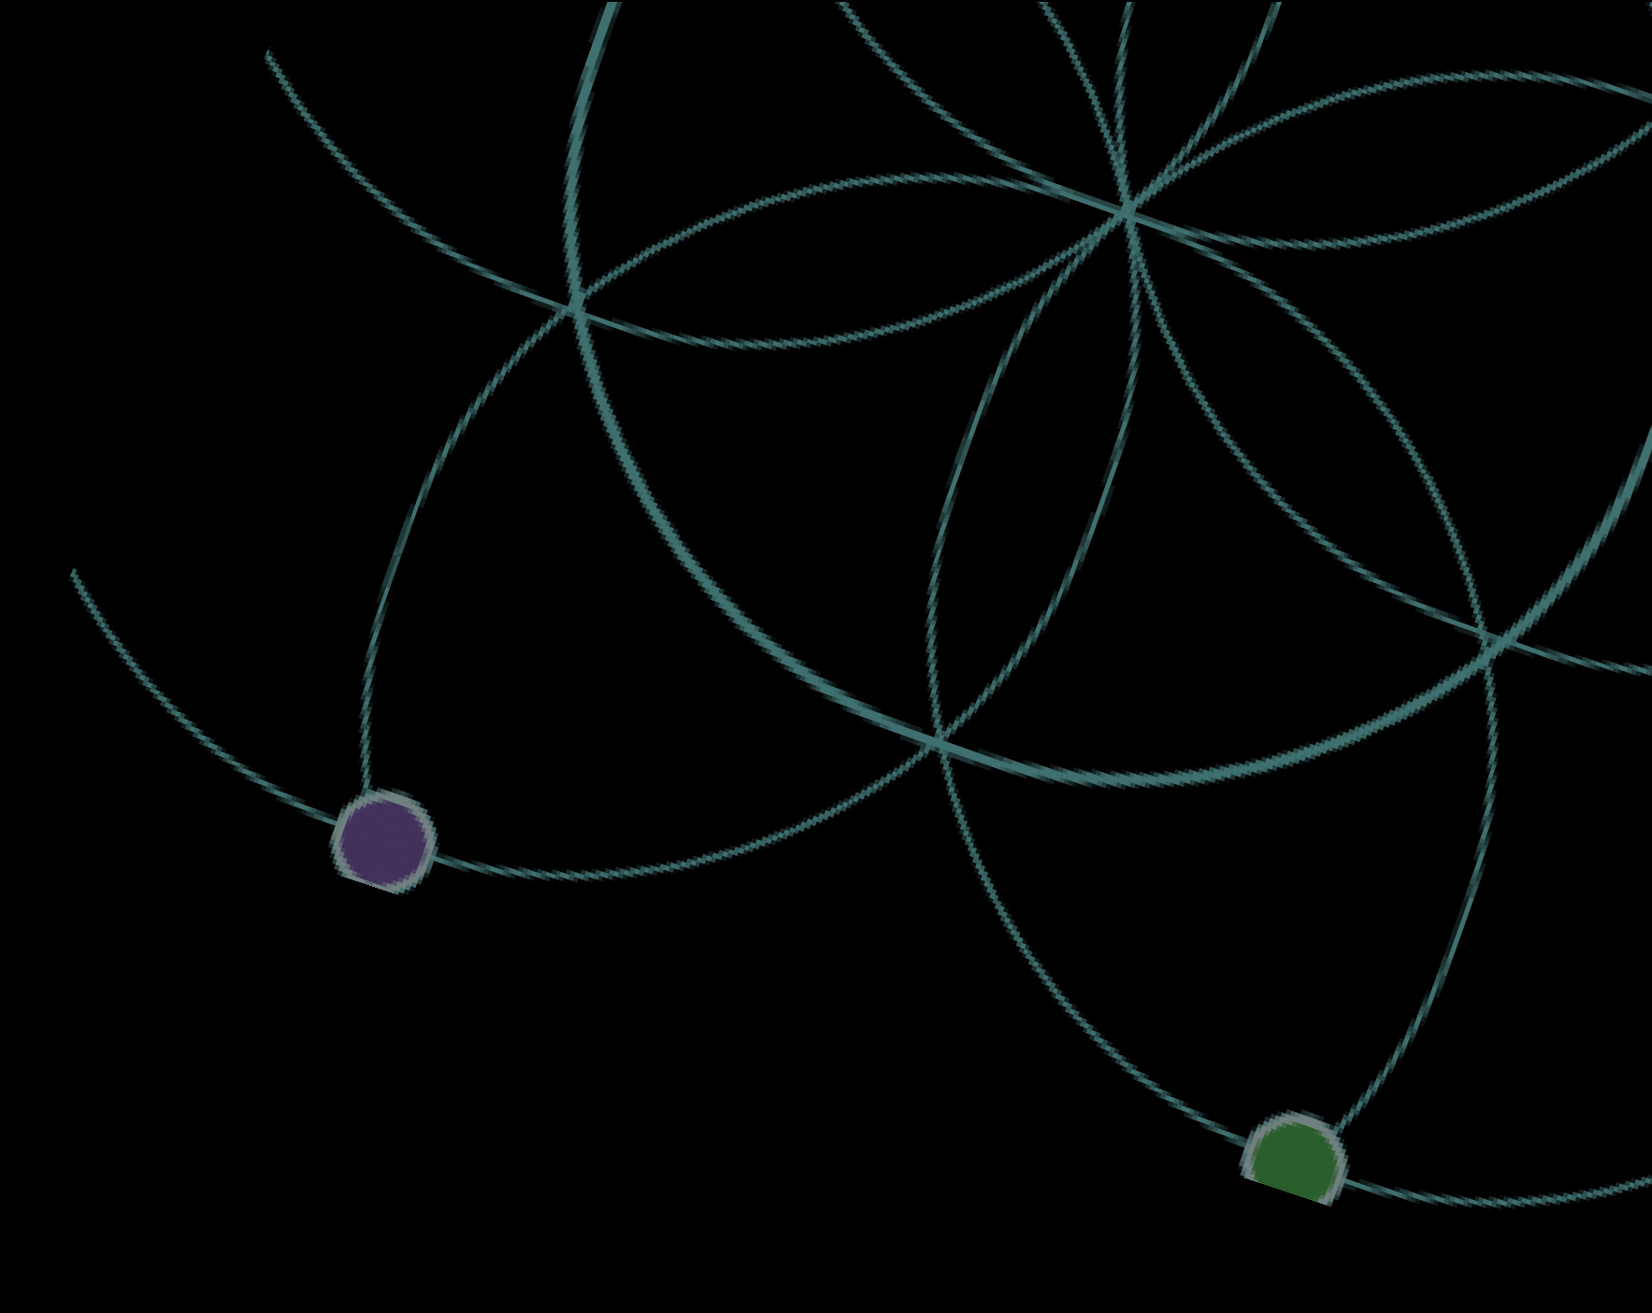

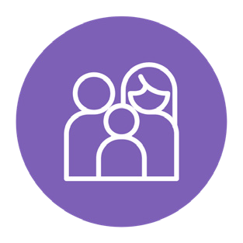
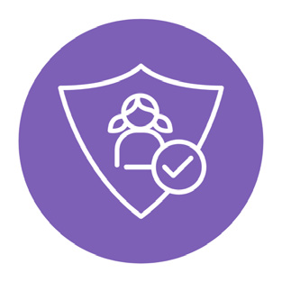




Choices is a national nonprofit committed to empowering individuals, engaging communities, and enhancing systems. Choices Indiana programs include: Children’s Mental Health Initiative (CMHI), Children’s Mental Health Wraparound (CMHW), Family Preservation Services, School-Based Services, Foster Care Solutions, Behavioral Health Solutions, Choices Emergency Response Team (CERT), and Kaleidoscope Recovery Services. Learn more at ChoicesCCS.org.

Contact
Sarah Rehfeldt 317.741.8837
Srehfeldt@ChoicesCCS.org

