
Multisystemic Therapy (MST®) is a family and community-based treatment that addresses the core causes of juvenile delinquency and antisocial behaviors, such as aggressive/violent behaviors, theft and other criminal behaviors, substance use, and chronic school problems. MST Therapists work around the clock to empower at-risk youth and their families to develop healthier environments, reducing unwanted behaviors and improving youth mental health, using existing strengths and resources.

Multisystemic Therapy (MST)

Proven outcomes include: Services are tailored to the

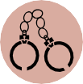
Reduced rates of criminal offending, arrests, and recidivism
Reduced rates of out-of-home placements

Extensive improvements in family functioning

LifeSolutions Counseling Associates is accepting referrals for Delaware, Hamilton, Johnson, Madison, and Marion Counties.

To refer families for MST, please send referrals through KidTraks under Family Preservation Services. Contact MST Supervisor Lauren Edwards for questions: lauren.edwards@optum.com

needs of the family and can include, but are not limited to, any of the following:
- Mental health interventions for youth, caregivers, couples & family
- 24/7 crisis intervention
- Youth & parent substance use treatment
- Peer management
- Parenting skills training
- Household management training
- Anger management
- Educational and vocational support
- Systems advocacy
Eligibility Criteria
We serve youth who are: Ages 12-17
At risk of severe system consequence (i.e., removal from home, arrest, expulsion) due to their challenging behaviors
Involved with Department of Child Services or the juvenile justice system

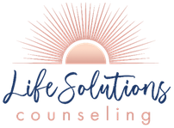

LifeSolutions MST Coverage

