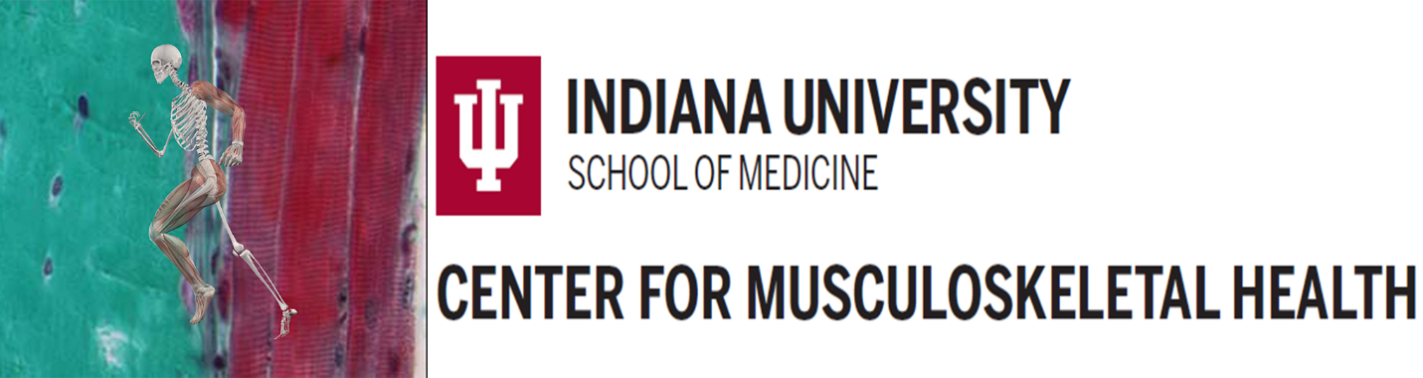

**ICMH Basic Science Resource Cores**

**FY25 Funding Program**

Application Deadline: **May 30,** **2025 at 11:59 p.m.**

Contact **Alex Robling arobling@iu.edu with RFA questions.**

**INFORMATION FOR APPLICANTS**

**GENERAL**

The goal of the Indiana Center for Musculoskeletal Health (ICMH) Basic Science Resource Core Pilot Funding Program is designed to promote the use of technologies and expertise afforded by the ICMH Basic Science Core Program (BSCP) to facilitate new research initiatives and encourage collaboration and cooperation among basic science researchers, and between basic and clinical science researchers, in the musculoskeletal field. Details about ICMH BSCP, its cores, and their services can be found at this link: <https://medicine.iu.edu/research-centers/musculoskeletal/basic-translational-science-service-cores>.

This funding opportunity announcement invites applicants holding a faculty position. The program is directed at new investigators seeking funds or for any investigator obtaining critical preliminary and/or feasibility data for a grant application or conducting pilot experiments to test a novel hypothesis.

Proposals with high potential of generating extramural funding and outstanding scientific merit will be judged highly. Applications must describe how an award will contribute to securing future extramural funding and specify the anticipated scope and sources of the funding. Applications to this grant mechanism may not exceed $25,000 proposed budget. Funded proposals are expected to generate new extramural grants or grant renewals that include the use of the ICMH BSCP.

**ELIGIBILITY**

All members holding a faculty position, regardless of tenure status, are eligible to apply. This includes faculty having primary appointment as Assistant Professor and above. This mechanism is not open to graduate students, postdoctoral fellows or visiting faculty.

**RESTRICTIONS**

* Facilities and administrative costs, or indirect costs, are not allowed.
* Faculty salary coverage is not allowed.
* Institutional support must be indicated by completion of all signatures on the application pages. Facsimile or electronic signatures are acceptable.

**APPLICATION GUIDELINES**

* A portion of the funding (20% minimum) must be used for core services offered by one of the 3 cores within the ICMH BSCP. Information about the cores is available at <https://medicine.iu.edu/research-centers/musculoskeletal/basic-translational-science-service-cores>. Please contact Alex Robling with any budgeting questions: [arobling@iu.edu](mailto:arobling@iu.edu).
* Other costs are allowable, including staff/student/postdoc salary, supplies, analysis costs, animal costs (per diem and purchasing), and fees for use of other ICMH cores outside of the BSCP (e.g., animal phenotyping core, CRC cores funded by the clinical P30, 3D bioprinting core, optical imaging core). Pilot funding may not be used for equipment purchases.
* The maximum allowable budget per proposal is $25,000. Provide a breakdown for personnel, supplies, and core usage, and other costs in a budget justification.
* Submissions may not exceed three single spaced 8.5 x 11 pages with at least 1/2 inch margins on all sides. Font must be Arial 11 points or larger. Successful applications will clearly describe how pilot funding from this mechanism will aid in starting a new project or strengthening a planned or pending grant submission, and how the Core services will be utilized in both the proposed study and the planned extramural grant submission. Preliminary data is not required. Applications should include the following sections within the 3 page limit:
  1. Title
  2. Project Summary/Abstract (300 word max; use layman’s terms)
  3. Research Plan, including BSCP core usage
  4. Feasibility
  5. Path to External Funding
* A references section should be included but is not counted in the 3-page limit.
* Biosketches from the PI and Key Personnel must be provided in the most recent NIH format, limited to 5 pages in length, and should include a personal statement relative to this proposal, positions, honors, contribution to science, active grants, and selected research projects that are most relevant to the proposed project.
* The Core Director must agree with the suitability of the project and the cost involved. A line of communication must be established via email that includes written confirmation from the Core Directors at the time of submission. Please contact Dr. Lilian Plotkin for the Histology & Histomorphometry Core ([stwarden@iu.edu](mailto:stwarden@iu.edu)), Dr. Yunlong Liu for the Systems Biology and Multi-Omics Core ([yunliu@iu.edu](mailto:yunliu@iu.edu)) and Dr. Alex Robling for the Musculoskeletal Mechanobiology Core ([arobling@iu.edu](mailto:arobling@iu.edu)).
* Proposals are due by Friday May 30, 2025 and are to be submitted via the ICMH Administrative Core webpage under the “Submit a pilot funding applicaiton” link. <https://medicine.iu.edu/research-centers/musculoskeletal/basic-translational-science-service-cores/administrative>. The number, size, and scope of the final Pilot Funding Awards will be determined by the ICMH BSCP leadership team.
* Projects should have a start date no earlier than July 1, 2025 and requested project period may not exceed 12 months.
* Summary of application components:
  1. Cover page (see Administrative Core website for download)
  2. Three page proposal
  3. References
  4. Bioskecthes
  5. Budget and budget justification
  6. Email correspondence from core director(s) indicating project suitability
* Upload competed applications using the link on the [BSRC Admin Core](https://medicine.iu.edu/research-centers/musculoskeletal/basic-translational-science-service-cores/administrative) page.

**Application Review information**

* Applications will be evaluated for scientific and technical merit by a scientific peer review committee composed of the ICMH leadership. As part of the scientific peer review, all applications will receive a written critique.
* The following will be considered in making funding decisions:
* Scientific and technical merit of the proposed project as determined by scientific peer review.
* Availability of funds.
* Proposed use of the ICMH BSRC Core/s
* Potential for subsequent external funding
* Relevance of the proposed project to program priorities.
* A formal notification in the form of an email will be provided to the applicant for successful applications.
* A Notice of Award will be provided to successful applicants once all PDT requests have been satisfied.
* Awardees will be required to present their work, funded by the pilot program, and the subsequent year’s ICMH retreat.
* Awardees will be required to submit a progress report at the completion of the 1 year of funding. The progress report must include publications, grants submitted, grants funded that used data generated by core, and intellectual property. This information will assist the ICMH in its eventual P30 grant renewal attempt.
* Grant recipients are required to acknowledge receipt of ICMH Basic P30 support in any presentation or publication of work funded by a Pilot Funding Award as follows:

*“This [publication was made possible / project was supported] by the Indiana Center for Musculoskeletal Health, funded in part by grant # P30 AR083854 from the National Institute of Arthritis and Musculoskeletal and Skin Diseases. The content is solely the responsibility of the authors and does not necessarily represent the official views of the National Institutes of Health."*