All IN for Health iConnect IRB Language Guide
Please Note: Not all information in this guide may apply to you. Suggested language and materials are based on IU IRB requirements. Please choose the sections that correspond with your needs. We encourage you to check with your institution/IRB of record if you have specific questions regarding requirements for your IRB submission. For questions, please contact the Indiana CTSI Admin Team at inhealth@iu.edu
-------------------------------------------------------------------------------------------------------------------------------
The following information is based on the current IU Human Subjects Office (HSO) forms and related to using the Indiana CTSI All IN for Health iConnect study listing and volunteer registry website as a recruitment tool. This information is provided to help you supplement your recruitment sections of your KC-IRB submission. You may need to alter this depending on which capabilities you are using in the system. Other investigational review boards may ask for additional information.
**Highlighted items are placeholders for the materials/information you may include with your IRB submission.
The following is a list of items that you may customize and include with your application:
- Document A: iConnect Trial Listing page (you will take a screenshot of your finalized study listing page to submit to your IRB)
- Document B: Volunteer Outreach Email Message Template
- Document C: Study Team Reply To Interested Volunteer Email Message Template
Recommended IRB Language for Using the All IN for Health iConnect study listings and registry website for recruitment
KC Protocols – Section “Eligibility and Recruitment”
Q. #0307: Describe your recruitment process…
Our study will be listed on the Indiana CTSI study listing called the All IN for Health Trial_{X} iConnect. iConnect is a HIPAA-compliant and secure public facing research recruitment platform provided by the Indiana Clinical and Translational Sciences Institute (Indiana University) consisting of a study trial listing and volunteer registry. This system is licensed by Indiana University from TrialX and is monitored by the Indiana University Information Technology Services (UITS) and University Information Security Office (ISO). Study Teams have access to their study listings and participant referrals based on a secure login. There is a small Administrative Team within the Indiana CTSI that manages the iConnect platform and has access to all study information, referrals, and registry volunteers. This online platform provides researchers with the ability to create a public facing webpage that can contain a brief prescreener and the ability for the public to refer themselves to the trial: (https://research.indianactsi.org). The study listing information can be modified based on the study and targeted population and provides a direct, easily managed system to enhance communication with the public. Study teams can also use this webpage as the landing or referral page for any marketing materials that are being used (either by listing the hyperlink or creating a scannable QR code). We have included a screenshot of our study listing for your review and approval. Please see attachment titled (insert Document A - file name of “iConnect study listing page” - screenshot file here).
The study listings are open to the public and any persons who visit our study page may submit their contact information to us through the listing. We can access that information by logging in to our iConnect dashboard. We may respond to and contact interested volunteers directly through the platform or by university phone or email. We will use the following guide for any email responses for phone conversations with the volunteers. For our standard messaging, please see attached [insert Document C- file name of “Study Team Reply Email Message Template”).
In addition to the study listing(s), potential participants will be identified from the Indiana CTSI All IN for Health voluntary registry IU IRB Protocol Number 1105005444. This registry was created so that interested individuals could create a volunteer profile to receive information about ongoing studies. Persons in this registry have provided their self-reported health information for the purposes of being matched to appropriate research studies. The registry volunteers have signed an electronic consent/authorization so that their information can be used and they can be contacted for this reason.
We can also match participants in the registry and are able to send out a message to them through the system in a de-identified manner. We may use the outreach search and filter tool in the system to identify a group of volunteers who match our study criteria based upon the information that the volunteers have included in their profiles. We may then send an outreach message to those de-identified matched volunteers through the online system. If we send an outreach message to matched volunteers, we will use standard messaging (please see attached [insert Document B - file name of “Volunteer Outreach Email Message Template.”] Matched volunteers who receive our outreach message and indicate they are interested and agree to be contacted specifically for this study will approve for their contact information to be accessible by us through the iConnect portal. If we contact those interested matched volunteers by email or phone, we will use the language from Document C [file name of “Study Team Reply Email Message Template”] for any email responses for phone conversations with the matched volunteers.

Document A: iConnect Trial Listing Page Screenshot
Below is an example screenshot of an iConnect Trial Listing page as it appears in the system. You will take a screenshot of your finalized listing page (this will be Document A) to submit to your IRB.
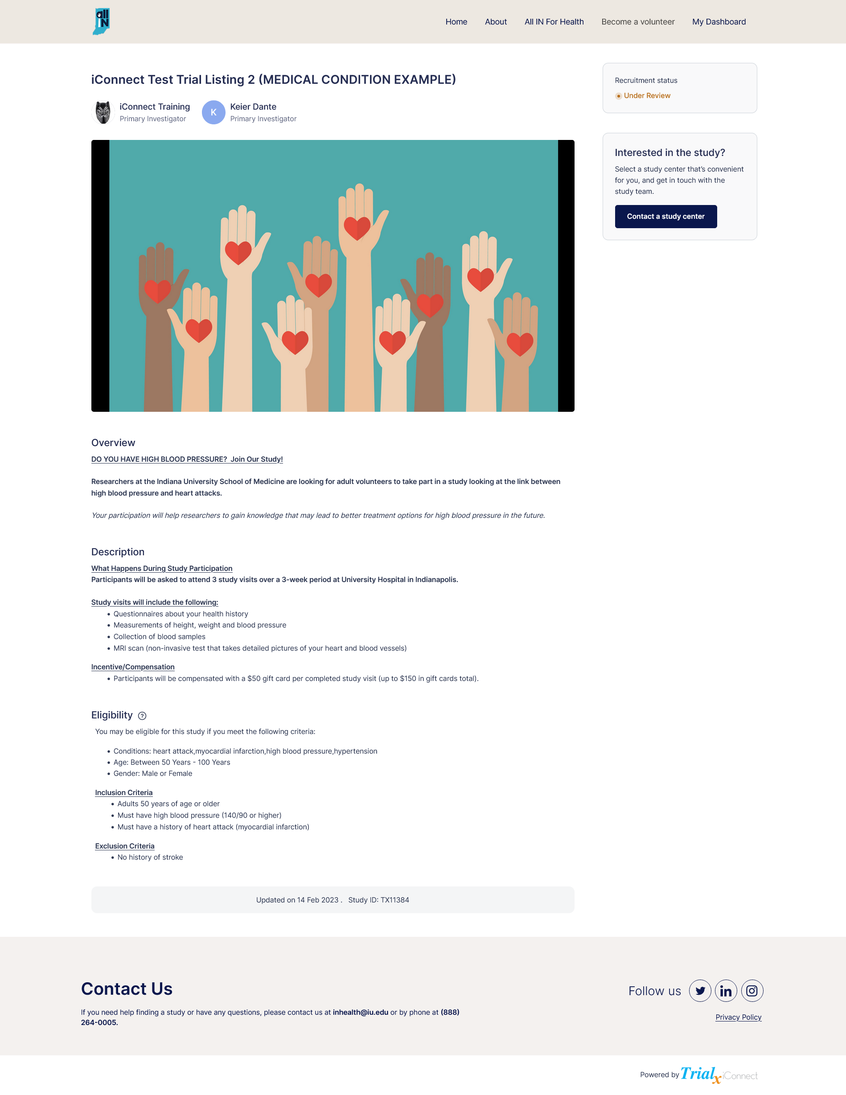
Document B: Volunteer Outreach Email Message Examples and Template
(To use when contacting registry volunteers via email outreach message through the iConnect system)
BLANK Volunteer Outreach Email Message Example
Below is a screenshot of how the Volunteer Outreach Email Message appears in the system in real- time with NO customizations added. Please refer to the Document B: Volunteer Outreach Email Message Template to use to draft your email text in document form to submit to your IRB.
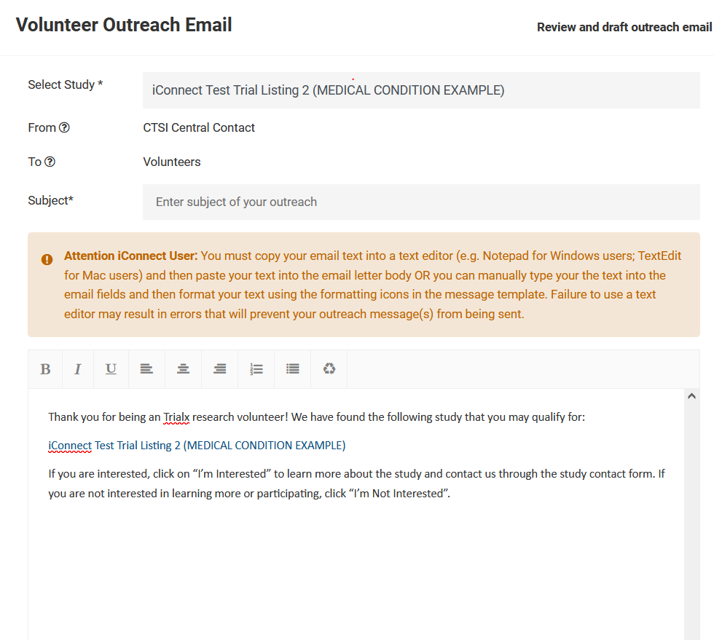

CUSTOMIZED Volunteer Outreach Message Example
Below is a screenshot of an example of a customized Volunteer Outreach Email Message as it appears in the system when created in real-time. Please refer to the Document B: Volunteer Outreach Email Message Template to use to draft your email text in document form to submit to your IRB.
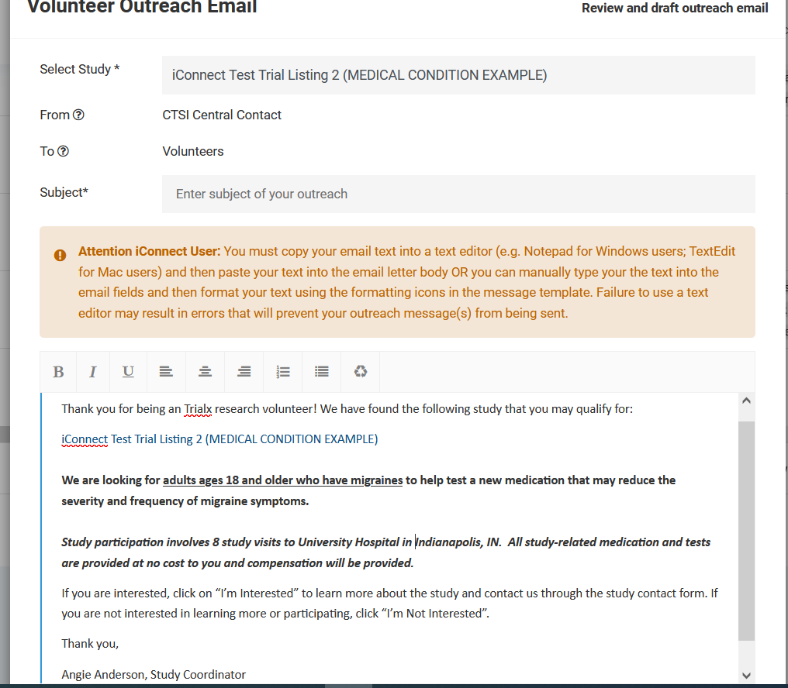

Document B: Volunteer Outreach Email Message Template
To be used to draft your email text in document form to submit to your IRB.
**Items in blue indicate that they are auto-populated by the system in the message and should not be changed or removed
**Items in red need to be customized/added to the message before sending
------------------------------------------------------------------------------------------------------------------------------
Select Study Title [you will select your study title from the drop-down menu]
From Study Team Member Name
To Volunteers
Subject: ADD CUSTOMIZED TEXT HERE (should be a short catchy tag-line that includes age and/or population with condition) –Examples: Research Study Looking For Children Ages 8-12 with Asthma; Study on Stress Looking for Adults Ages 18 and Older; Healthy Volunteers Needed for Brain and Behavior Study
Thank you for being an TrialX volunteer! We have found the following study that you may quality for:
STUDY LISTING PAGE HYPERLINK
ADD CUSTOMIZED TEXT HERE (we recommend adding some brief information about your study right below your study listing hyperlink, such as the goal of your study, who are you looking for, and what participants will be expected to do. Example: Our study is looking for people who are between the ages of 55-88 who have had a stroke in the past 5 years to help test a new medication that may reduce post-stroke symptoms. All study-related medication and tests will be provided at no cost to you and compensation will be provided).
If you are interested, click on “I’m Interested” to learn more about the study and contact us through the study contact form. If you are not interested in learning more or participating, click “I’m Not Interested.”
Thank you,
Name, Title and/or Study Team

Document C: Study Team Reply To Interested Volunteer Email Message
(To use when responding to volunteer replies/inquiries via email messages)
**This message is fully customizable. The template below is the general format we recommend using. Items in red brackets need to be customized/added to the message. You may add additional info or directions for your volunteer(s) as needed.
To be used to draft your email reply text in document form to submit to your IRB.
------------------------------------------------------------------------------------------------------------------------------------------
Message Template
Hi [participant name],
We are reaching out to you because we received your information indicating that you may be interested in participating in our study.
Our research study called [short or user-friendly title] is looking for [criteria, condition, study population].
The goal of this study is to [short statement of study focus or purpose].
If you/your child are eligible and choose to participate, you will be asked to [brief description of what participation involves].
When is a good time for us to reach out to you about this study? Please [call/email] us back and let us know your availability.
Thank you for your interest in our study!
[Name and Title or Study Team Name and Contact Information]

CUSTOMIZED Study Team Reply To Interested Volunteer Email Message Example
------------------------------------------------------------------------------------------------------------------------------------------
Hi John,
We are reaching out to you because we received your information indicating that you may be interested in participating in our study.
Our research study is looking for children, ages 8-12, who have been diagnosed with asthma.
The goal of this study is to further evaluate a new treatment that may help reduce asthma flare-ups and symptoms in children.
If your child is eligible and chooses to participate, they will be asked to attend 6 study visits at our lab in Bloomington, IN. During the visits, your child will undergo a brief physical exam and some blood samples will be taken. We will ask you to fill out some questionnaires about your child’s health and asthma history/symptoms.
You/your child will receive up to $350 for completing all of the study requirements.
When is a good time for us to reach out to you about this study? Please call or email us back and let us know your availability. Please be sure to leave a message so that we can return your call.
Thank you for your interest in our study!
Asthma Study Team
(317) 555-5555
Asthma_study@noemail.com

